Wang Qingsong studio www.wangqingsong.com
Fall Newsletter 2011-11-16

- (2011年纽约时报报道) Wang Qingsong’s latest work, “Goddess”, 180x250cm, c-print, 2011, was featured on LOOK Session on NY Times Sunday Magazine, Oct. 16, 2011.
http://www.nytimes.com/interactive/2011/10/16/magazine/LOOKchina.html

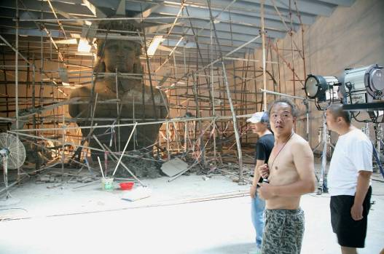
Shooting process
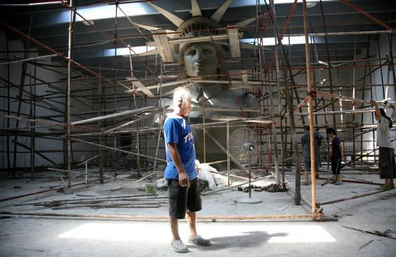
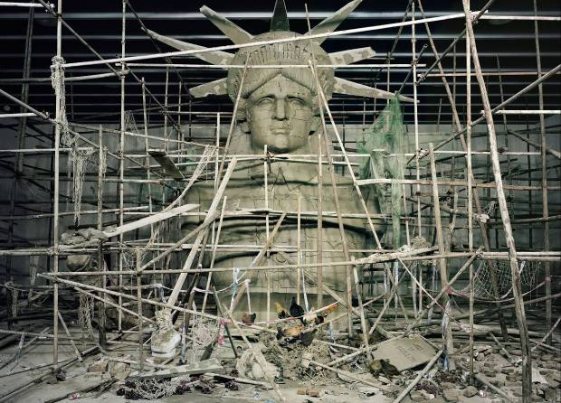
HEIGHT OF PLASTER MODEL: 24 inches
AMOUNT OF CLAY USED FOR FULL-SIZE STATUE: more than 20 tons
CONSTRUCTION DURATION: 22 days
TIME NEEDED TO DISMANTLE: 7 days
NUMBER OF CHICKENS USED IN PHOTO SHOOT:18 to 20

Approaching the Statue of Liberty by boat for the first time in 1999, Wang Qingsong had visions of Botticelli. ‘‘It was just a little bit like ‘The Birth of Venus,’ ’’ he said. ‘‘It was a goddess born from the water.’’ Twelve years later, he took that image as inspiration for ‘‘Goddess,’’ featuring a 26-by-19-foot clay sculpture built in his studio in Songzhuang, an artists’ village on the outskirts of Beijing. As with all of his work, Wang constructs elaborate tableaux, which he then photographs and dismantles. For ‘‘Goddess,’’ he imagined Lady Liberty in a Mao suit, a reflection of China’s struggle between two ideals: the beliefs of the chairman and the tenets of democracy. The scaffolding around the sculpture alludes to the vast unfinished construction sites in China; the chickens that wander through the rubble enjoy a freedom that he believes the Chinese people do not. Though he has had only a few direct confrontations with the authorities (usually over nudity), Wang expects ‘‘Goddess’’ to be controversial. ‘‘People have lost their dreams and their ideals,’’ he said. ‘‘As an artist, as a citizen, I am very puzzled about where we are going and why we are lost.’’ --- Julie Bosman

2. （2011年中国连州国际摄影节展览）Wang Qingsong, “Toward the Social Landscape”, Lianzhou Photo Festival, Nov. 19-Dec. 8, 2011, Guangdong Province, China. Curated by Christopher Phillips, curator of International Center of Photography, New York City, and Duan Yuting, the founder of Lianzhou Photo Festival. This will be the first major debut of Wang Qingsong’s photo works in this photo festival, consisting of 11 photographs, mostly staged shots inspired from the observations of social realities, a way of shooting called by the artist, “New Social-Documentary”. http://www.lianzhoufoto.com/en/ArtistDetails.aspx?id=36

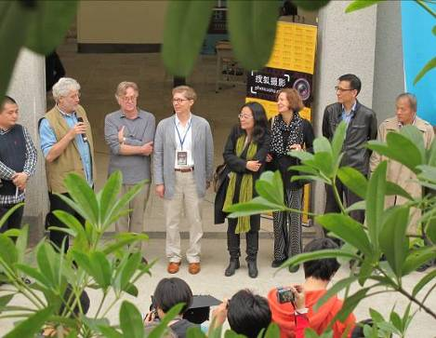
（Opening：Zhang Xiang’Ou, Robert Pledge, Charles Traub, Christopher Phillips, Duan Yuting, Vicki Goldberg, Jiang Rong, Wang Qingsong）
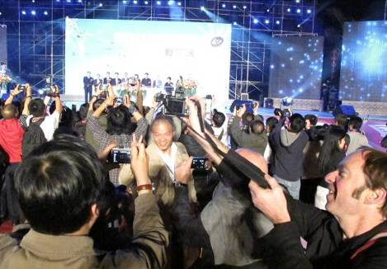
(Official opening night, Wang Qingsong)

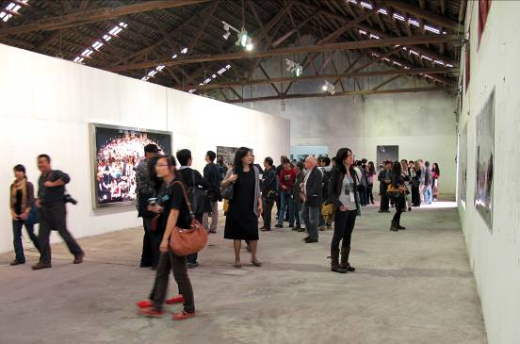
（Wang Qingsong solo exhibition）

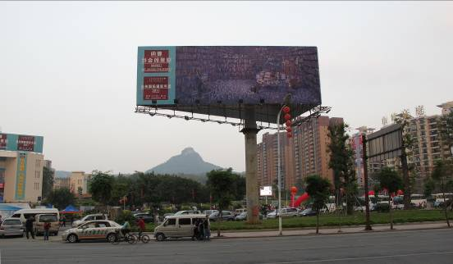
（“Follow Him” by Wang Qingsong as the poster for the festival Square in the major Avenue in Lianzhou ）

- （2011年意大利卢卡国际摄影节：看东方）Wang Qingsong, “LOOK EAST”, Lucca Photo Festival, Nov. 19- Dec. 19,2011. About 10 large-scale photos will be displayed in this beautiful little town in South Italy.
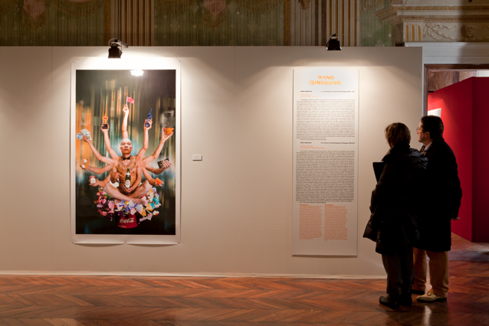

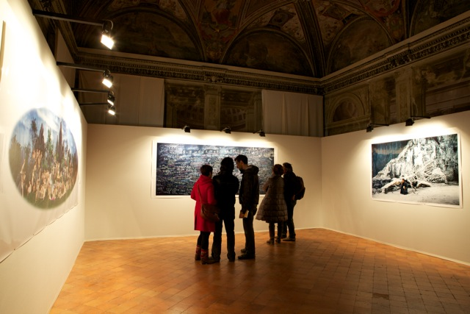

- （2011年中国北京唐人画廊个展）Wang Qingsong, “Happy New Year”, Tang Contemporary Art, 2011. 12.17-2012.2.18, Address: 798 Art District, Jiuxianqiao Road, Chaoyang District, Beijing

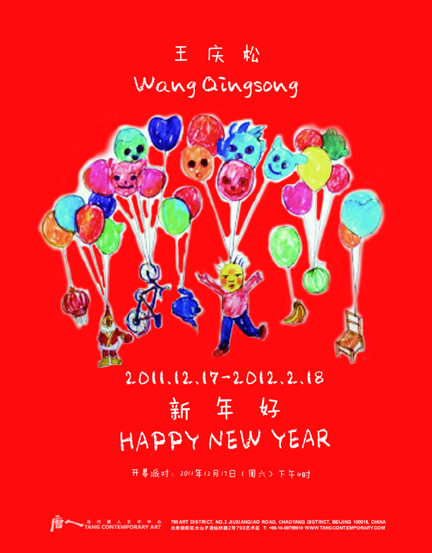

Collaborated with Tang Contemporary staff, Wang Qingsong installs three scenarios of bliss and gloss. In the 12-meter-high room, Qingsong fills up the 500-square-meter giant space with nearly 3000 balloons, featured in worldwide loveable cartoon figures, such as Pooh, Happy Goats, Teddy Bear, as well as merry-go-around, bike, sport games, sewing machine, cradle, and etc…Qingsong invites audience to interact with the space by incorporating festivities of Merry Christmas, Happy New Year and Chinese Lunar New Year all together in this singular blown-up hype atmosphere.

The second room, however, is made of a barbed-wire spider web on which daily garbage, boxes, bottles, stationeries, papers, plastic, are hung up. This small enclosed space works for audience to meditate on a second-hand wheelchair. This smaller space presents a mythical contradiction against the colorful jubilee in the large hall.

In the third space, Qingsong presents three nearly toned-down monochromatic photo works, “Home” (2005), “Poisonous Spider” (2005) and “Goddess” (2011). Renowned as a blockbuster “social documentary” photographer, Qingsong challenges viewers to face up harsh realities. In “Home”, Qingsong cripples into a house, dilapidated with troves of trash stuffed in cracks of broken-walls, illuminating on the vested interest of modern development. In “Poisonous Spider”, daily consumables are lured onto the web by the power spider, played out by the artist. In “Goddess”, we confront with a determined Statue of Liberty in Mao suit, entrenched into worn-out scaffoldings in a rejected construction site, with dozens of chickens looking for something lost. These three grim images portend an unpredictable panorama of what we have done, what we are doing and what we will face up to in the meandering river of history. Is 2012 arriving along with catastrophes, predestined by the ancient Maya civilization?

The show runs from December 17, 2011 until February 18, 2012.

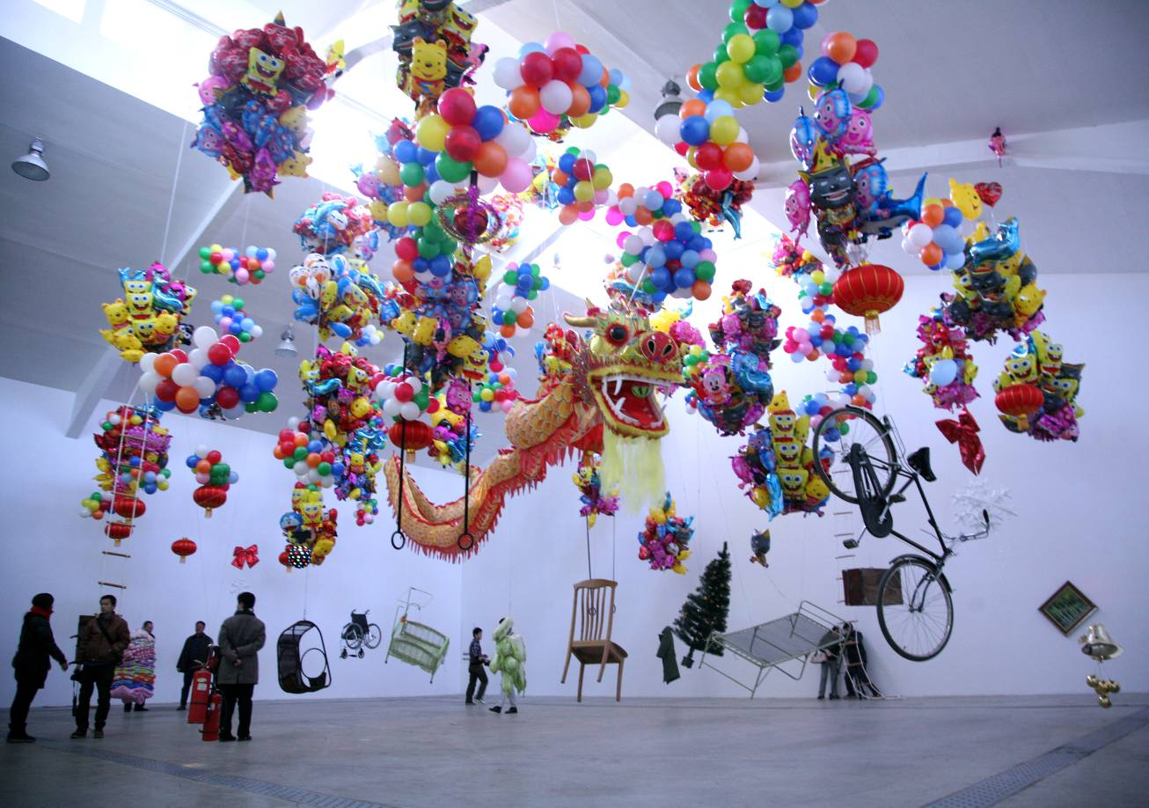
Exhibition in Tang Contemporary Art

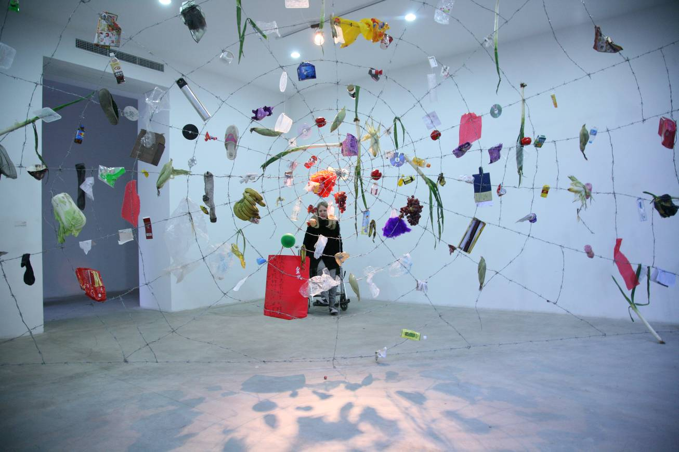
Installation of a small-scale “Poisonous Spider”, Steel Mesh, Garbage, dimension variable, 2011

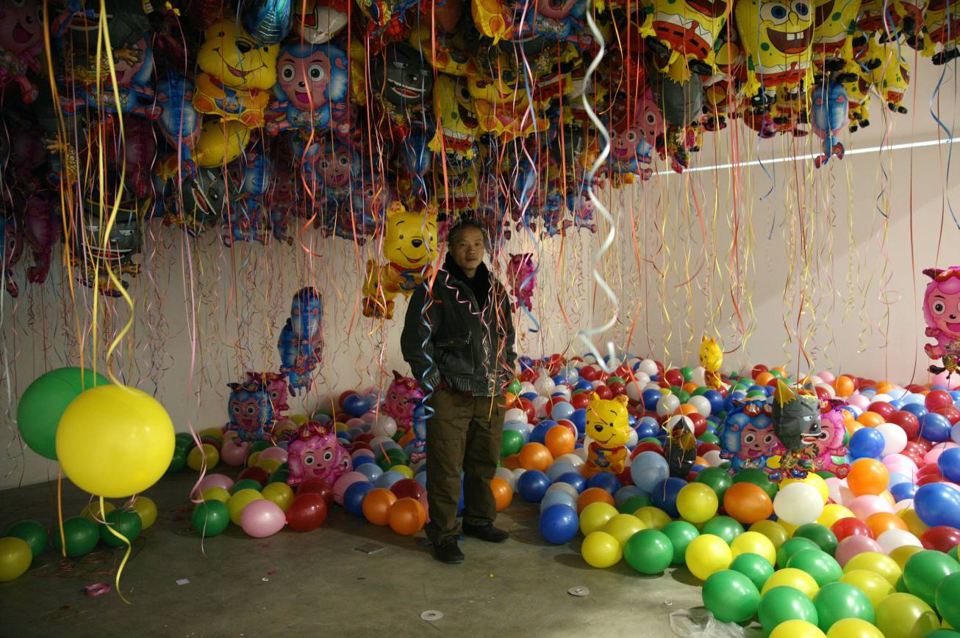
Wang Qingsong stands among the balloons.

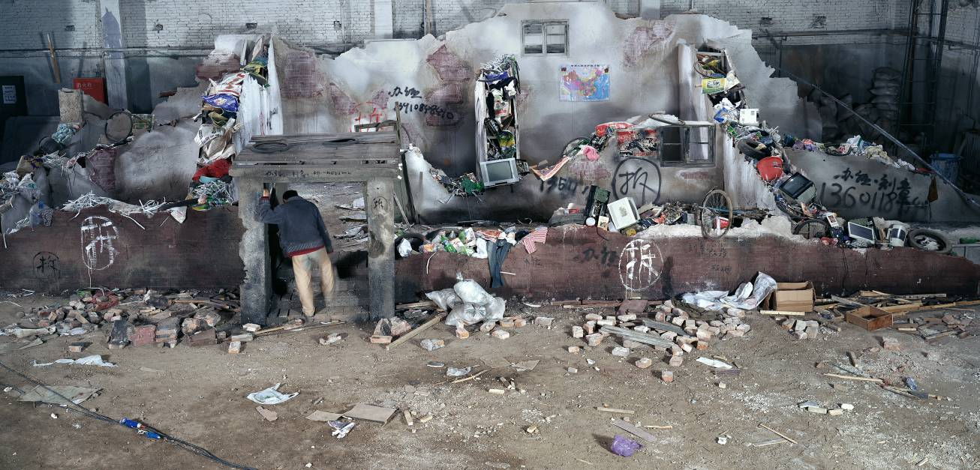
Home, 120x250cm, 2005

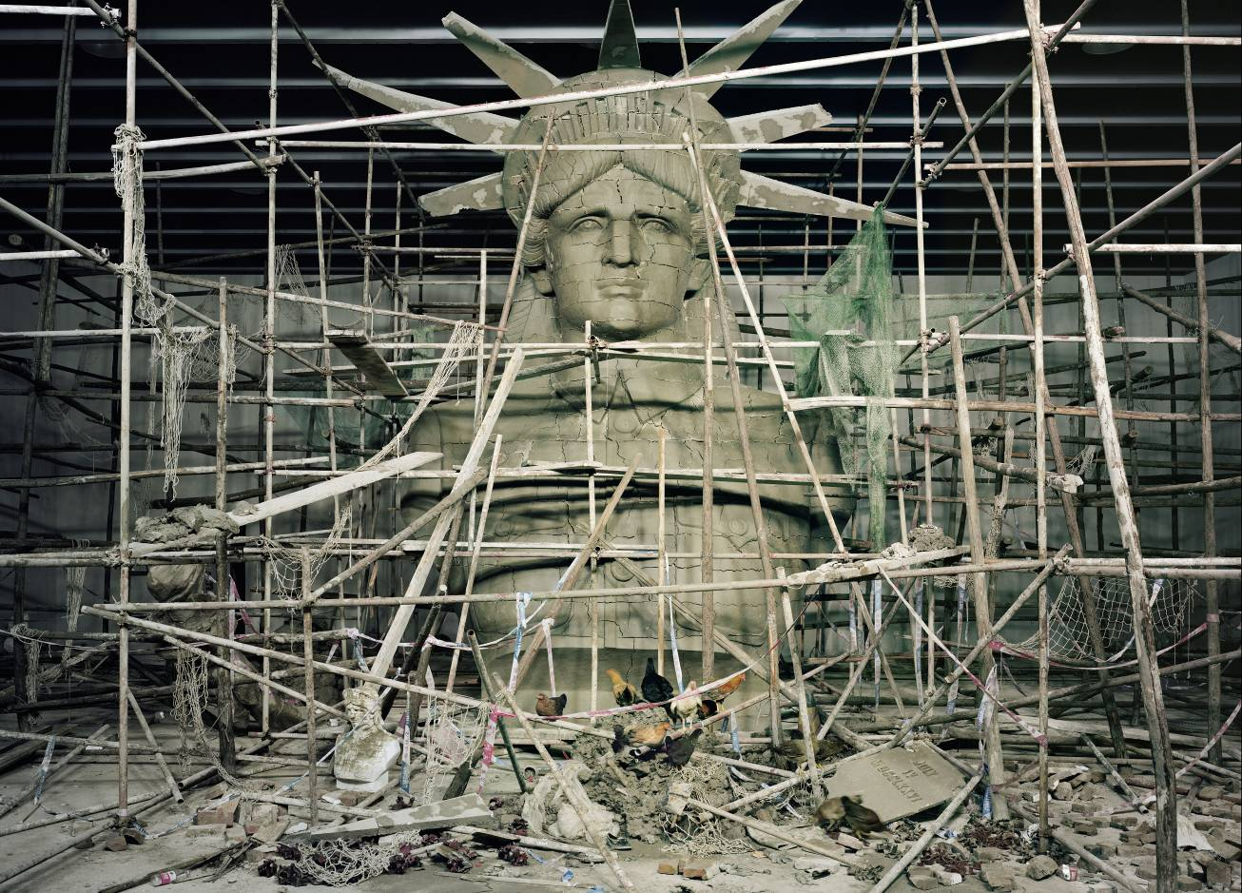
Goddess, 180x250cm, 2011

